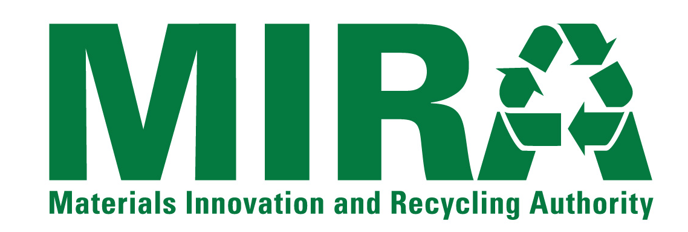
STATEMENT OF QUALIFICATIONS FORM

PROJECT: | Connecticut Solid Waste System
RFQ NUMBER: | 15-OP-001
CONTRACT FOR: | CSWS South Meadows Units 5 and 6 Power Purchase Agreement
BID SUBMITTED TO: | Material Innovation and Recycling Authority  100 Constitution Plaza, 6th Floor  Hartford, Connecticut 06103-1722

DEFINITIONS
Unless otherwise defined herein, all terms that are not defined and used in this Statement of Qualification Form (a “SOQ”) shall have the same respective meanings assigned to such terms in the Contract Documents.

TERMS AND CONDITIONS
The undersigned (the “Submitter”) accepts and agrees to all terms and conditions of the Request For Qualifications, Instructions To Submitters, and any Addenda to any such documents.

SUBMITTER’S REPRESENTATIONS CONCERNING EXAMINATION OF CONTRACT DOCUMENTS
In submitting this SOQ, Submitter represents that:
- Submitter has thoroughly examined and carefully studied the RFQ Package Documents and the following Addenda, receipt of which is hereby acknowledged (list Addenda by Addendum number and date):
Addendum Number | Date Issued

- Submitter is fully informed and is satisfied as to all Laws And Regulations that may affect cost, progress, performance, furnishing and/or completion of the activities contemplated by the Contract Documents;
- Submitter has studied and carefully correlated Submitter’s knowledge and observations with the Contract Documents and such other related data;
- Submitter has given MIRA written notice of all conflicts, errors, ambiguities and discrepancies that Submitter has discovered in the Contract Documents;
- If Submitter has failed to promptly notify MIRA of all conflicts, errors, ambiguities and discrepancies that Submitter has discovered in the Contract Documents, such failure shall be deemed by both Submitter and MIRA to be a waiver to assert these issues and claims in the future;
- Submitter is aware of the general nature of activities to be performed by MIRA and others that relates to the activities for which this SOQ is submitted; and
- The Contract Documents are generally sufficient to indicate and convey understanding by Submitter of all terms and conditions for performing and completing the activities for which this SOQ is submitted.

SUBMITTER’S REPRESENTATIONS CONCERNING INFORMATION MADE AVAILABLE
In submitting this SOQ, Submitter acknowledges and agrees that Submitter shall not use any information made available to it or obtained in any examination made by it in connection with this RFQ in any manner as a basis or grounds for a claim or demand of any nature against MIRA arising from or by reason of any variance which may exist between information offered or so obtained and the actual conditions encountered during performance of any of the activities.

SUBMITTER’S REPRESENTATIONS CONCERNING DISCLOSURE OF INFORMATION
In submitting this SOQ, Submitter:
- Recognizes and agrees that MIRA is subject to the Freedom of Information provisions of the Connecticut General Statutes and, as such, any information contained in or submitted with or in connection with its SOQ is subject to disclosure if required by law or otherwise; and
- Expressly waives any claim(s) that Submitter or any of its successors and/or assigns has or may have against MIRA or any of its directors, officers, employees or authorized agents as a result of any such disclosure.

SUBMITTER’S REPRESENTATIONS CONCERNING NON-COLLUSION
By submission of this SOQ, the Submitter, together with any affiliates or related persons, the guarantor, if any, and any joint ventures, hereby represents that, under risk of disqualification from this auction process, to the best of its knowledge and belief:
- No attempt has been made or will be made by the Submitter to induce any other person, partnership of corporation to submit, or not to submit, a SOQ for the purpose of restricting competition;
- Submitter has not directly or indirectly induced or solicited any other person, partnership of corporation to submit a false or sham SOQ; and
- Submitter has not sought by collusion to obtain for itself any advantage for the award of the contract contemplated by this RFQ over any other Submitter or over MIRA.

SUBMITTER’S REPRESENTATIONS CONCERNING RFQ FORMS
By submission of this SOQ, the Submitter, together with any affiliates or related business entities or persons, the guarantor, if any, and any joint ventures, hereby represents that, under risk of disqualification from the procurement process all of the forms included in the RFQ that are submitted to MIRA as part of its SOQ are identical in form and content to the preprinted forms in the RFQ Package Documents except that information requested by the forms has been inserted in the spaces on the forms provided for the insertion of such requested information.

SUBMITTER’S WAIVER OF DAMAGES
Submitter and all its affiliates and subsidiaries understand that by submitting a SOQ, Submitter is acting at its and their own risk and Submitter does for itself and all its affiliates, subsidiaries, successors and assigns hereby waive any rights any of them may have to receive any damages for any liability, claim, loss or injury resulting from:
- Any action or inaction on the part of MIRA or any of its directors, officers, employees or authorized agents concerning the evaluation, selection, non-selection and/or rejection of any or all SOQs by MIRA or any of its directors, officers, employees or authorized agents;
- Any agreement entered into for the Net Energy (or any part thereof) described in the Contract Documents; and/or
- Any award or non-award of a contract for the Net Energy (or any part thereof) pursuant to the Contract Documents.

SUBMITTER’S REPRESENTATION REGARDING THE CONNECTICUT CAMPAIGN CONTRIBUTION AND SOLICITATION BAN
With regard to a State contract as defined in P.A. 07-1 having a value in a calendar year of $50,000 or more or a combination or series of such agreement or contracts having a value of $100,000 or more, the authorized signatory to this submission in response to MIRA’s RFQ expressly acknowledges receipt of the State Elections Enforcement Commission’s notice advising prospective state contractors of state campaign contribution and solicitation prohibitions, and will inform its principals of the contents of the notice. See Section 5.2 and Exhibit 2 [SEEC Form 11] of the RFQ Package Documents.

ATTACHMENTS
The following documents are attached hereto and made a part of this SOQ:
- The completed SOQ Form;
- The completed Background Questionnaire Form;
- The completed Questionnaire Concerning Affirmative Action, Small Business Contractors, and Occupational Health and Safety Form;
- The completed Background Questionnaire that has been completely filled out by the submitter and signed before a Notary Public or Commissioner of the Superior Court;
- The completed Background, Experience and Financial Information Form;
- The Affidavit Concerning Nondiscrimination that has been completely filled out by the Submitter and signed before a Notary Public or Commissioner of the Superior Court;
- The Iran Certification Form that has been completely filled out by the Submitter and signed before a Notary Public or Commissioner of the Superior Court; and
- The completed Business Exceptions Form;

NOTICES
Communications concerning this SOQ should be addressed to Submitter at the address set forth below.
Submitter Name:
Submitter Contact:
Title:
Street Address 1:
Street Address 2:
City, State, Zip Code
Telephone Number:
Fax Number:
E-Mail Address:

ADDITIONAL REPRESENTATION
Submitter hereby represents that the undersigned is duly authorized to submit this SOQ on behalf of Submitter.
AGREED TO AND SUBMITTED ON |  | , 20 | 14

Name of Submitter (Firm):
Signature of Submitter Representative:
Name (Typed/Printed):
Title (Typed/Printed):

